Be Air Aware – Air Quality in Texas

Ground-level ozone harms the health of humans, wildlife, and vegetation. For this reason, the U.S. Environmental Protection Agency (U.S. EPA) set requirements on how much ozone is allowed to be in the air, primarily to protect your health. Ground-level ozone is a colorless and odorless gas which forms when nitrogen oxides (NOx) and volatile organic compounds (VOCs) in the lower levels of the atmosphere combine and “cook” in the sun. The NOx that contributes to the formation of ozone is produced from operating engines, electric power plants, and other industrial facilities, such as cement kilns. VOCs come from chemicals such as gasoline, paint, asphalt and other solvents.

According to the U.S. Environmental Protection Agency (US EPA) “…several groups of people are particularly sensitive to ozone, especially when they are active outdoors. This is because ozone levels are higher outdoors, and physical activity causes faster and deeper breathing, drawing more ozone into the body”. Increased levels of ground-level ozone can reduce lung function and affect the respiratory system. People most sensitive to increased ozone are active adults who work or exercise outdoors, children, older adults, and people with some form of lung disease like asthma.

Ozone Action Days are called by the Texas Commission on Environmental Quality when ozone levels are expected to reach unhealthy levels and you can subscribe to these alerts at https://www.tceq.texas.gov/airquality/monops/ozone_email.html. However, individuals can increase their awareness of air quality levels by regularly checking the Air Quality Index (AQI) at www.airnow.gov.
Most Ozone Action Days occur during ozone season which runs from Aril to October.

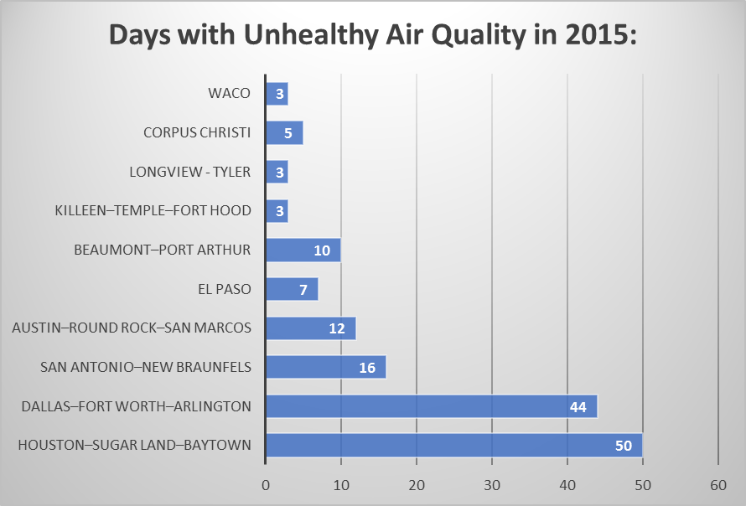
Figure 1 shows the number of day that air quality was considered unhealthy

On days when air quality is unhealthy people should try to reduce their exposure by restricting their time outdoors as much as possible and not exerting themselves when they are outdoors. There are also a number of actions that we can take to reduce the number of days in which air quality is poor like:
- Replace old fleet vehicles and equipment with those that run on a cleaner fuel
- Tune-up gasoline and diesel powered fleet vehicles and equipment regularly
- Reduce vehicle and equipment idling to less than 5 minutes
- Encourage employees to use alternative transportation to work, such as mass transit, bike, walk, or carpool
- Help employees partner to travel together during the work day by linking trips
- Use and store gasoline properly
- Use water efficiently

For more information about ground-level ozone visit the following websites:
U.S. EPA: http://www.epa.gov/groundlevelozone/
Texas Commission on Environmental Quality: http://www.tceq.texas.gov/airquality/monops/ozonefacts.html

