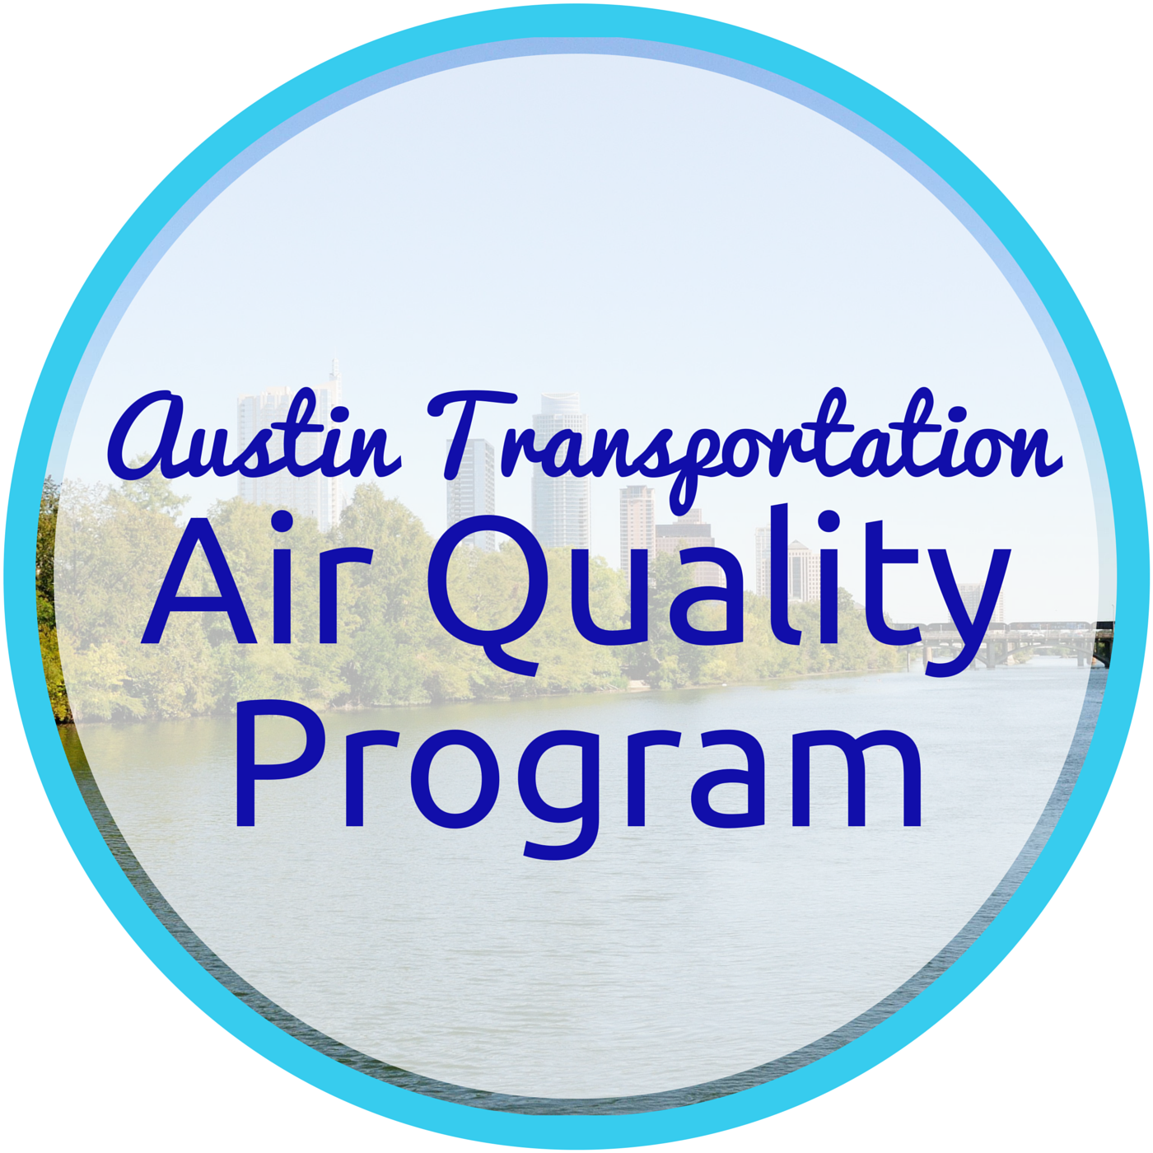 Tomorrow, Try Leaving Home Without It

Keep your car parked and try getting around by bus or train. Doing this even just once or twice a week could make a big difference. When you drive, you have to concentrate on the road, the traffic, the real world. But when you take transit, you can escape into a world far from stress and pressure.

You can benefit by:
- Having a little extra time to yourself to catch up on email, read, or take a nap.
- Saving money by decreasing driving costs.
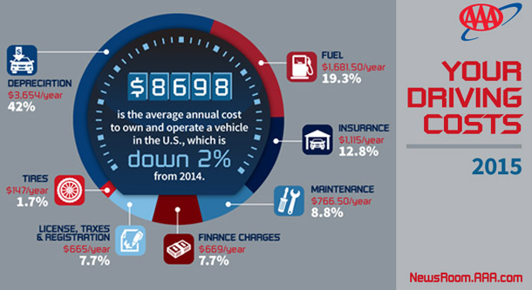
- Helping to reduce traffic congestion and keep the air clean, which actually makes your transit fare a contribution towards a better environment.

Every time you choose not to drive alone it adds up to cleaner air. Check out Commute Solutions to learn more.

